**My Project Output**

#1) Setting working directory

setwd("C:/Users/Rajat/Desktop")

#2) Read the data using read.csv

cities.df <- read.csv(paste("smartcities.csv", sep=""))

data <- read.csv(paste("smartcities.csv", sep=""))

#3) View the data frame in R

View(cities.df)

#4) Summary of the data

summary(cities.df)

#5)mean,median and standard devition

library(psych)

describe

#6)Histogram for showing Total Population By state

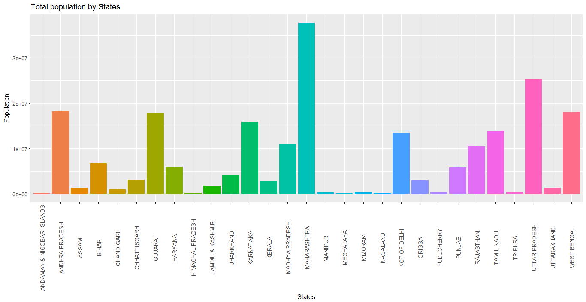

#7)Histogram showing total population of male and female #male & female population by states

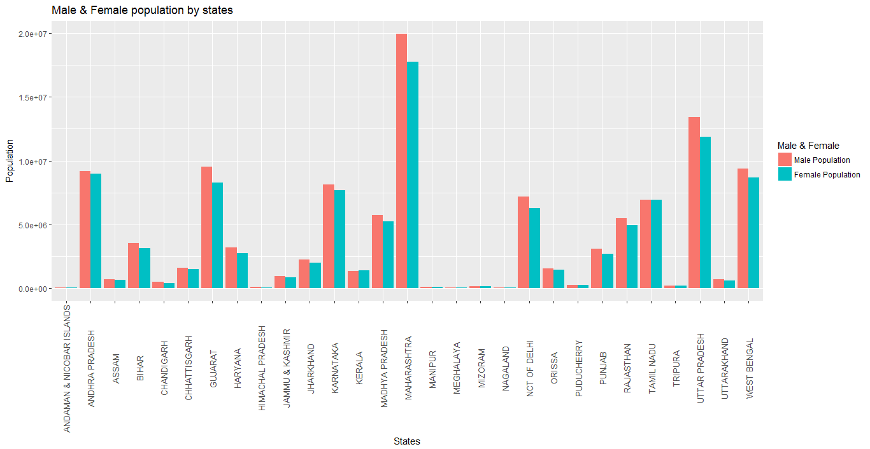

#8)Hisogram showing Differance in Male & Female Effective Literacy rate by states

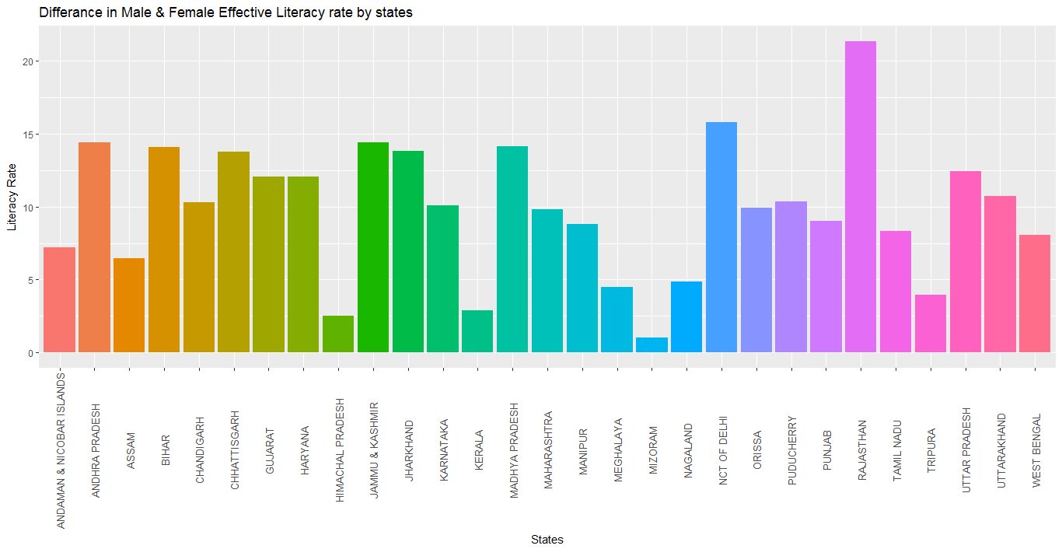

#9)#How many male and female literates are in each state?

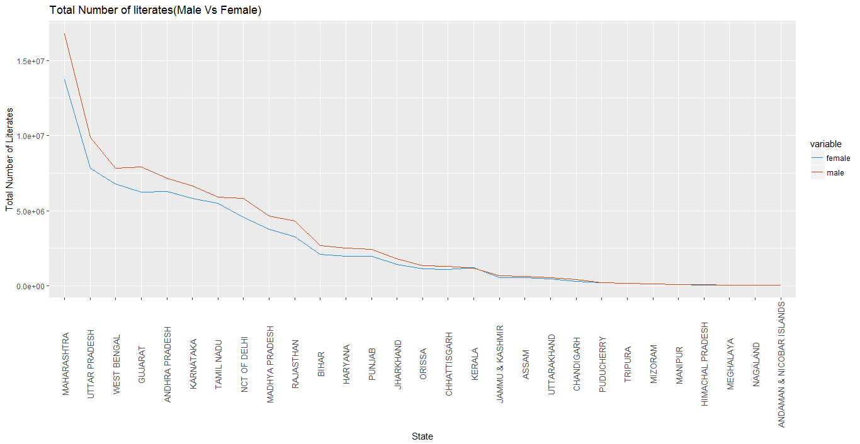

#10)#Literacy Rate Comparison Male Vs Female

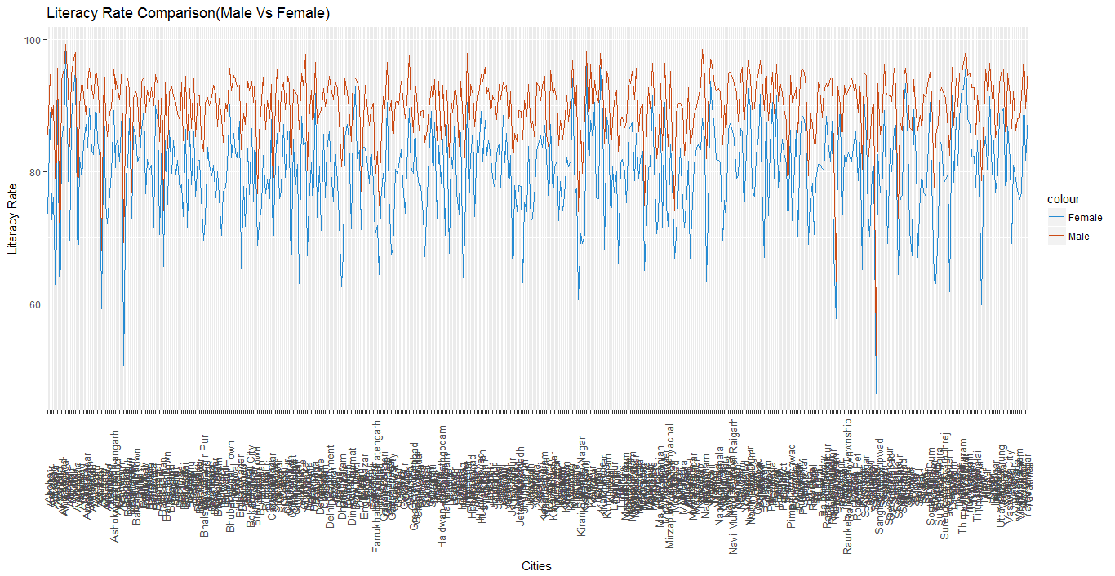

#11)# Sex Ratio and Child Sex Ratio

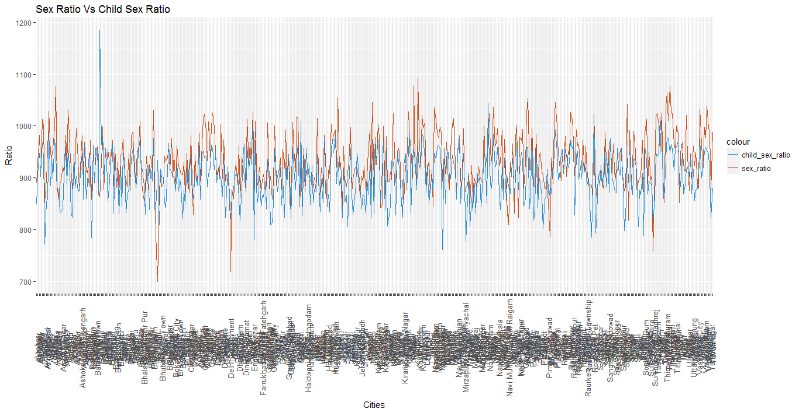

#12)#What are the top 10 most populated cities in India?

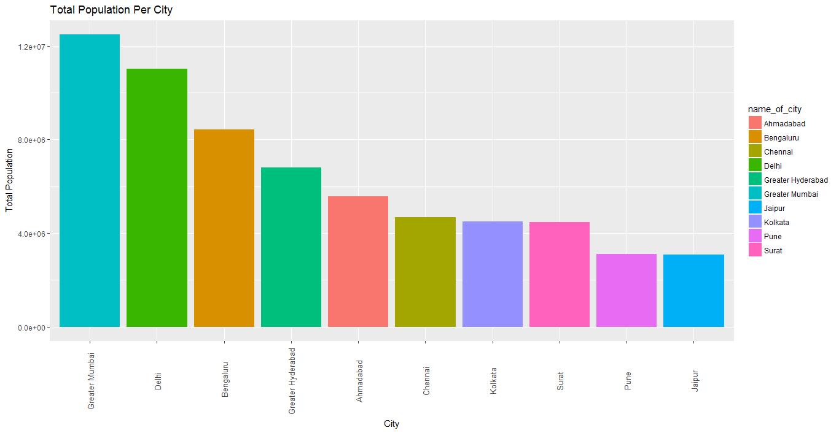

#13)bwplot for sex ratio for cities

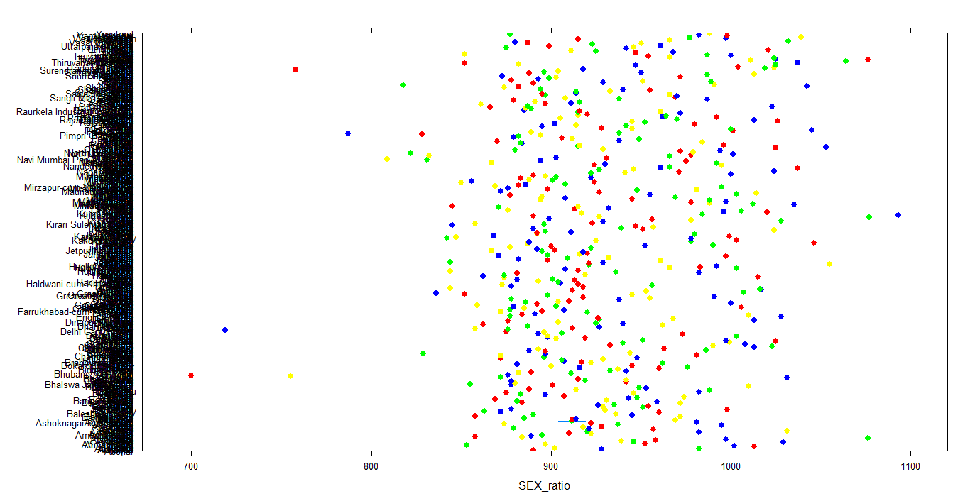

#14)bwplot for sex_ratio for states

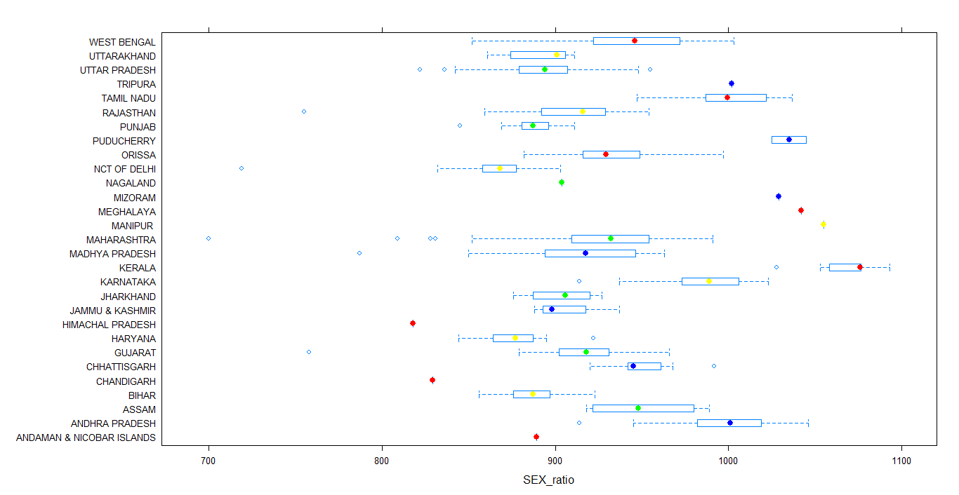

#15)bwplot for effective_literacy rate female

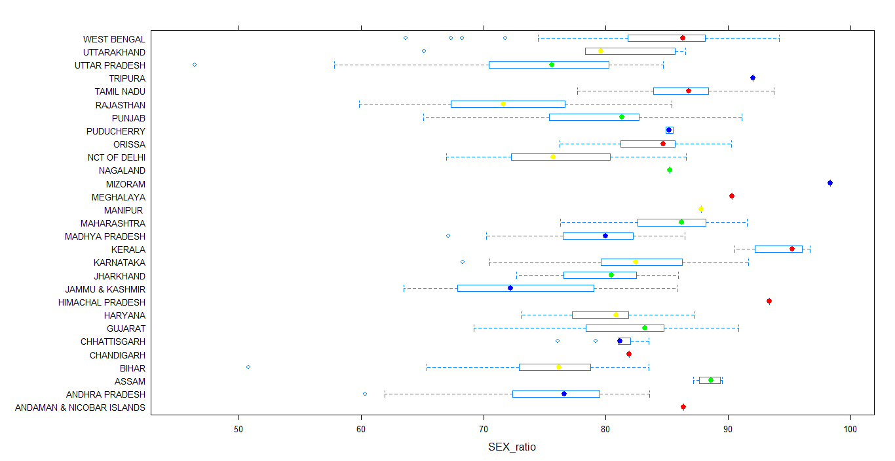

#16)bwplot for child sex ratio

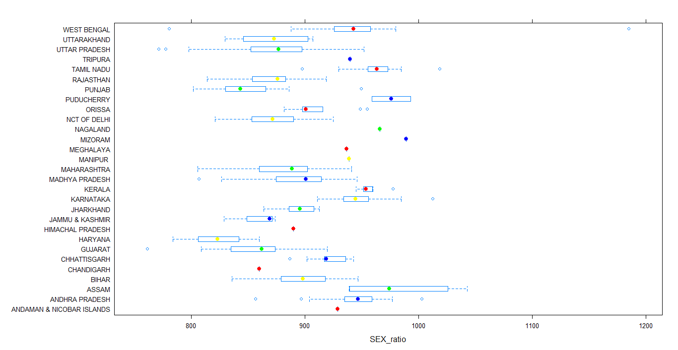

#17)bwplot for effective literatcy rate total

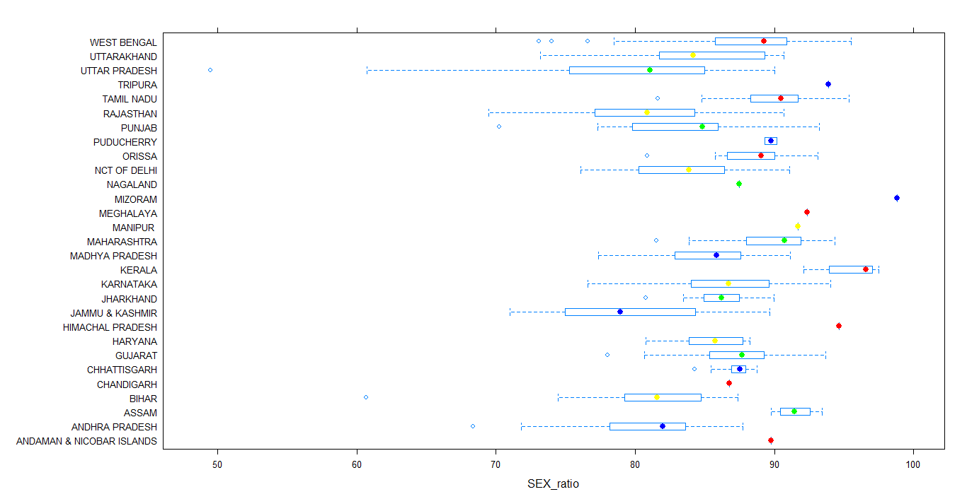

#18)scatter plot for sex_ratio and child sex ratio

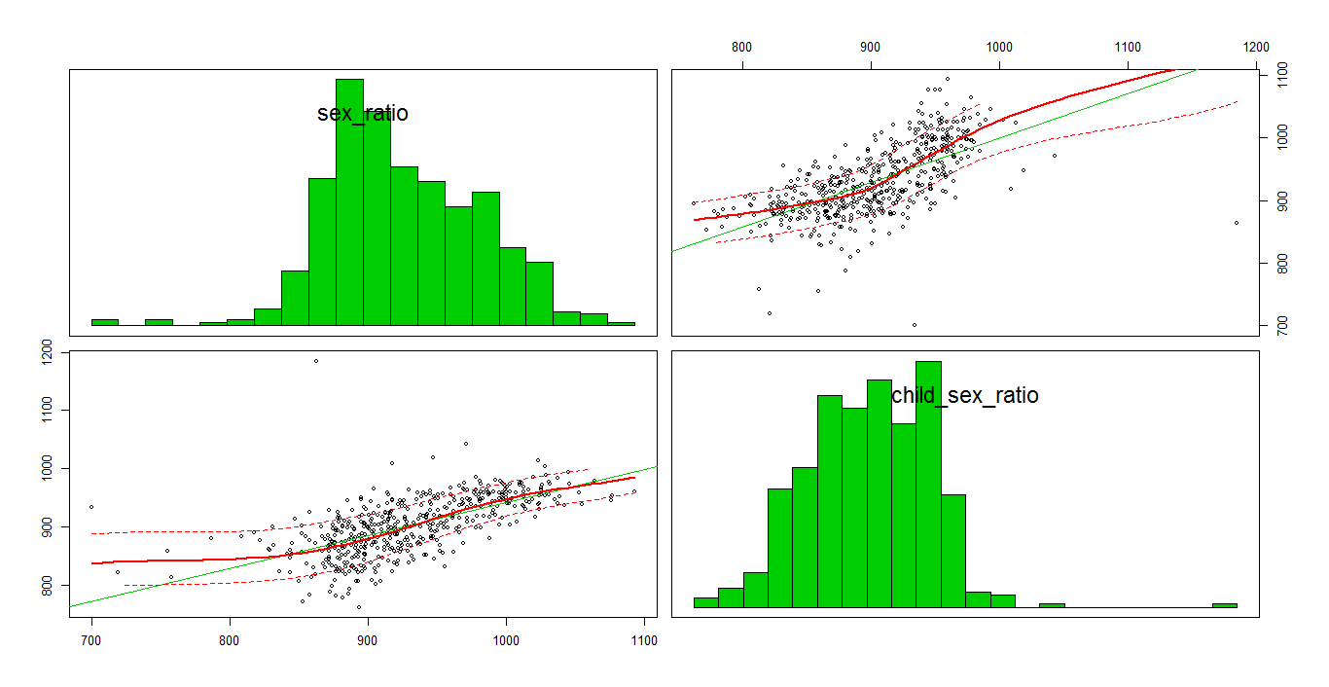

#19)scatter plot for sex_ratio and effective literatcy rate total

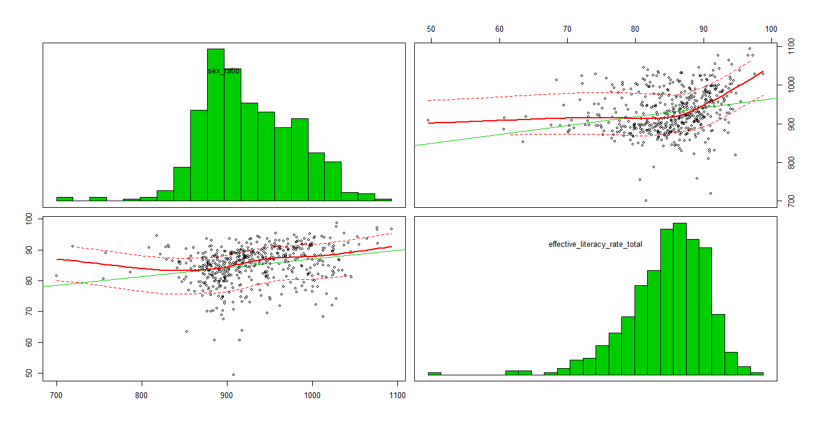

#20)scatter plot for sex_ratio and effective_literacy rate female

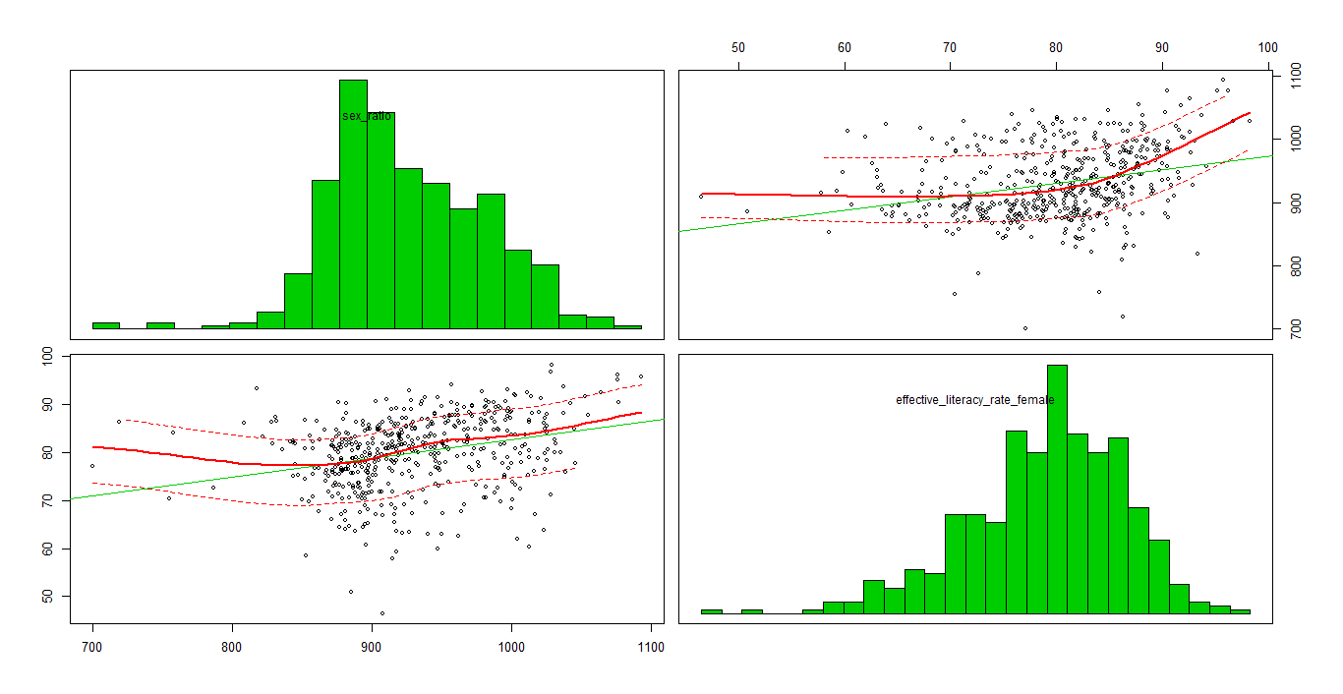

#21)corrgram

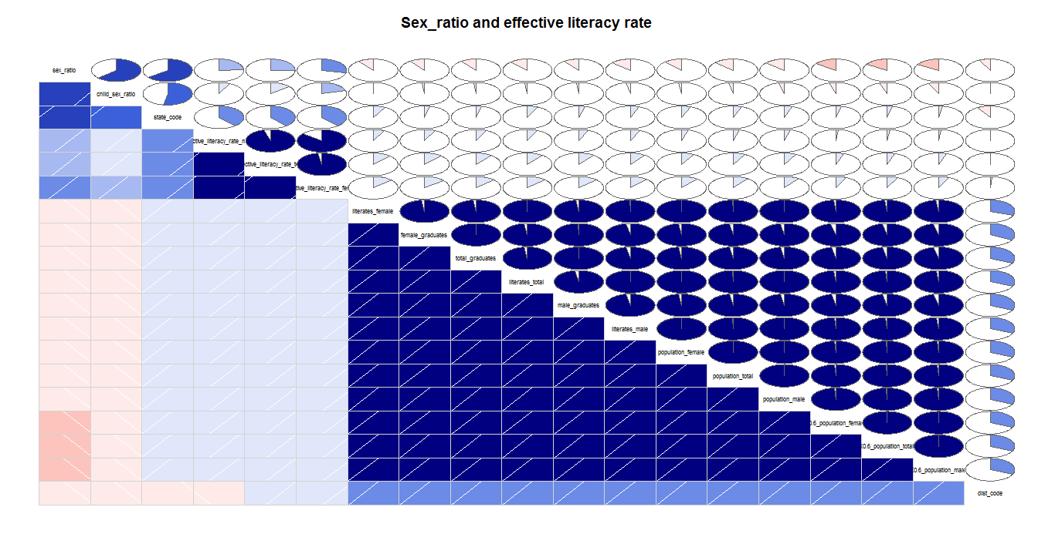

#22)covvariance matrix

|  |
| --- |
| > cov(cities.df$sex_ratio,cities.df$effective_literacy_rate_female)  [1] 121.9359 |
|  |
| |  | | --- | |  | |

#23)regression model

> fit <- lm(sex_ratio ~ effective_literacy_rate_female +effective_literacy_rate_total+child_sex_ratio, data=cities.df)

> summary(fit)

Call:

lm(formula = sex_ratio ~ effective_literacy_rate_female + effective_literacy_rate_total +

child_sex_ratio, data = cities.df)

Residuals:

Min 1Q Median 3Q Max

-257.483 -22.004 2.172 25.076 105.805

Coefficients:

Estimate Std. Error t value Pr(>|t|)

(Intercept) 170.24857 53.16482 3.202 0.00145 **

effective_literacy_rate_female -0.37618 1.13532 -0.331 0.74053

effective_literacy_rate_total 1.98357 1.37481 1.443 0.14972

child_sex_ratio 0.68851 0.04049 17.005 < 2e-16 ***

---

Signif. codes: 0 ‘***’ 0.001 ‘**’ 0.01 ‘*’ 0.05 ‘.’ 0.1 ‘ ’ 1

Residual standard error: 42.27 on 489 degrees of freedom

Multiple R-squared: 0.4308, Adjusted R-squared: 0.4273

F-statistic: 123.3 on 3 and 489 DF, p-value: < 2.2e-16